Technical Design Document - ETL Job Monitoring Agent
AI-Powered Data Engineering Copilot
- Executive Summary
The ETL Job Monitoring Agent is an AI-powered system that enables users to monitor, validate, and trigger ETL pipelines using natural language.
The solution eliminates the need for manual SQL queries by leveraging:
- LangChain Agent Framework
- Groq LLM (moonshotai/kimi-k2-instruct)
- Model Context Protocol (MCP)
- Hybrid transport architecture (HTTP + STDIO)
The system acts as a conversational data engineering assistant capable of:
- Monitoring job health
- Triggering ETL pipelines intelligently
- Inspecting database schema
- Performing CRUD operations
- Validating job execution health
- Problem Statement
In traditional ETL monitoring:
- Engineers manually query databases
- SQL knowledge is required
- Pipeline re-runs may cause duplication
- Schema inspection requires technical intervention
The goal was to build:
| A conversational AI agent that can monitor and control ETL workflows using natural language.
- System Architecture
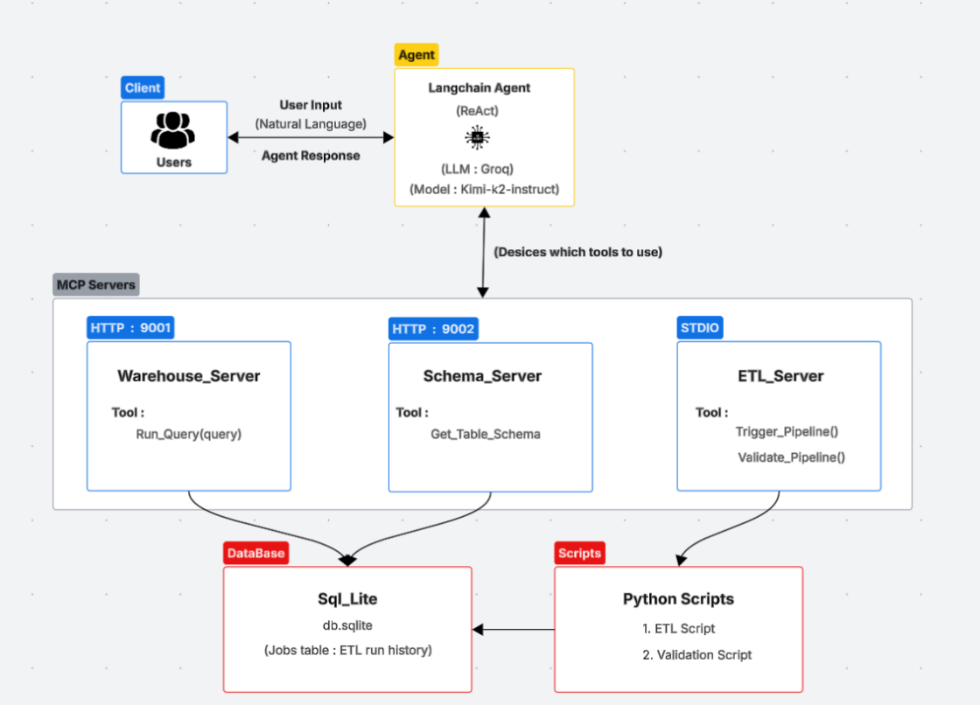
  - High-Level Architecture
  - Architecture Pattern
The system follows a Hybrid MCP Architecture:
Components | Transport | Purpose
Warehouse Server | HTTP | Executes SQL queries
Schema Server | HTTP | Returns table metadata
ETL Server | STDIO | Pipeline logic & validation

- HTTP servers allow scalability and independent deployment
- STDIO server keeps sensitive pipeline logic local
- Separation of concerns improves maintainability

- Technology Stack
Layer | Technology
Agent Framework | LangChain
LLM | Groq (kimi-k2-instruct)
Tool Protocol | Model Context Protocol (MCP)
Database | SQLite
Transport | HTTP + STDIO
Language | Python 3.12

- Component-Level Design

  - Agent Layer (main.py)
Responsibilities:
- Initializes MCP clients
- Loads tools from servers
- Configures Groq LLM
- Runs interactive conversation loop
- Routes tool calls via LangChain
Tool Routing Flow
- User asks question
- LLM analyzes intent
- LLM selects tool
- Tool executed via MCP
- Response returned to agent
- Final answer generated

  - Warehouse HTTP Server (Port 9001)
Tool: run_query
Responsibilities:
- Execute SQL queries
- Commit write operations
- Return structured results
Design considerations:
- All write operations use conn.commit()
- Schema check enforced via system prompt
- Absolute DB path used to prevent file errors
  - Schema HTTP Server (Port 9002)
Tool: get_table_schema
Responsibilities:
- Return table structure
- Prevent column mismatch errors
- Assist LLM in constructing valid queries
Purpose:
| Reduces hallucinated SQL errors
  - ETL STDIO Server
Tools:
- trigger_pipeline
- validate_pipeline
Responsibilities:
- Smart job re-run logic
- Prevent duplicate entries
- Update failed jobs only
- Health validation reporting

- Pipeline Execution Strategy
The system implements idempotent pipeline execution logic.

Condition | Behavior
Table not exists | Create table + run all jobs
No jobs run today | Insert fresh records
Some jobs failed | Update failed jobs only
All succeeded | Skip execution

Design Benefit:
Prevents duplication and ensures safe re-execution.
- Database Design
Table: jobs
Column | Type | Purpose
id | INTEGER | Primary key
job_name | VARCHAR | Job identifier
status | VARCHAR | SUCCESS / FAILED
start_time | TIMESTAMP | Execution start
end_time | TIMESTAMP | Execution end
created_at | TIMESTAMP | Record timestamp

Design Decisions
- Single table for simplified demo architecture
- Status tracking for validation logic
- Timestamps allow health analysis
- Tool Invocation Lifecycle
- User input received
- LLM parses intent
- Tool selected
- MCP client sends request
- Server executes logic
- Response returned
- LLM formats final answer
This ensures:
- Clear separation between reasoning and execution
- Reduced hallucination risk
- Deterministic tool behavior
- Error Handling Strategy

Issue | Solution
DB file error | Absolute DB path
Missing table | Auto-create logic
Schema mismatch | Mandatory schema check
Duplicate jobs | Smart UPDATE strategy
Write not persisting | Explicit commit()

- Performance Considerations
- HTTP servers allow horizontal scaling
- Stateless SQL execution
- Tool-based architecture reduces LLM token usage
- Temperature set to 0 for deterministic output
- Key Design Strengths
- Hybrid MCP architecture
- Tool-based deterministic execution
- Idempotent pipeline logic
- LLM hallucination mitigation
- Clear separation of concerns

- Conclusion
The ETL Job Monitoring Agent demonstrates:
- Practical application of AI in data engineering
- Agentic workflow design
- Hybrid protocol architecture
- Production-minded design decisions
The system successfully enables conversational ETL monitoring while maintaining control, safety, and modularity.

